Mule Soft Connection
In Mule after creating the project add azure service bus connectors. There will be two modules add both.
We will not be using Shared Access signature but Azure AD for authenticating the request.
Azure Active directory
- Create a app registration in azure portal. Search app registration in azure portal, click create a app registration and give it a name. Also select accountype.
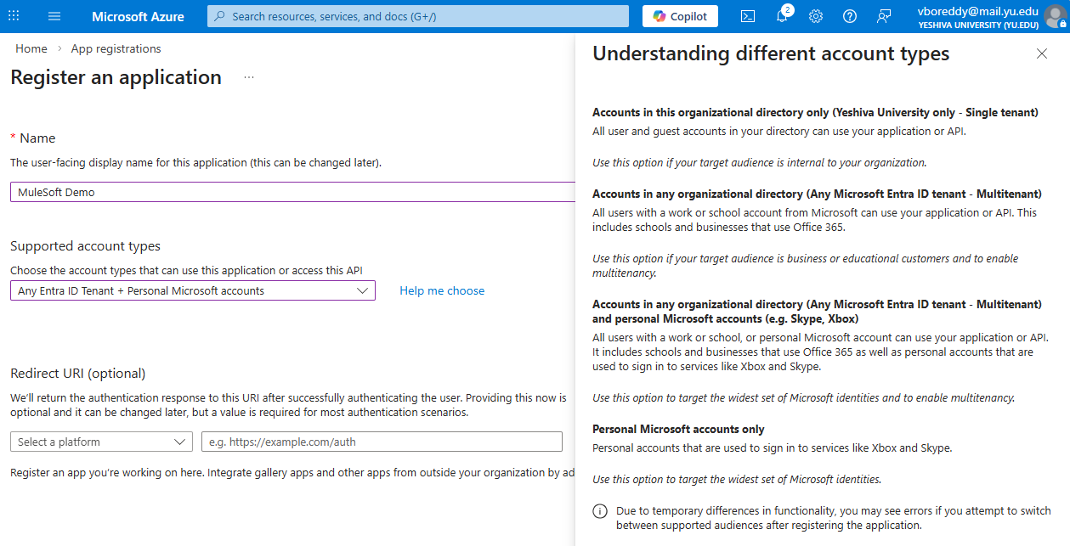
- We will get tenant id and client id from here.
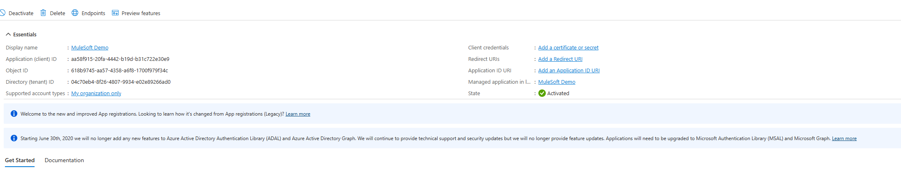
- Next, we have to create a client secret.
  - Got to manage and got to certificates and secrets.
  - Select create secret
  - Give description and expiry time

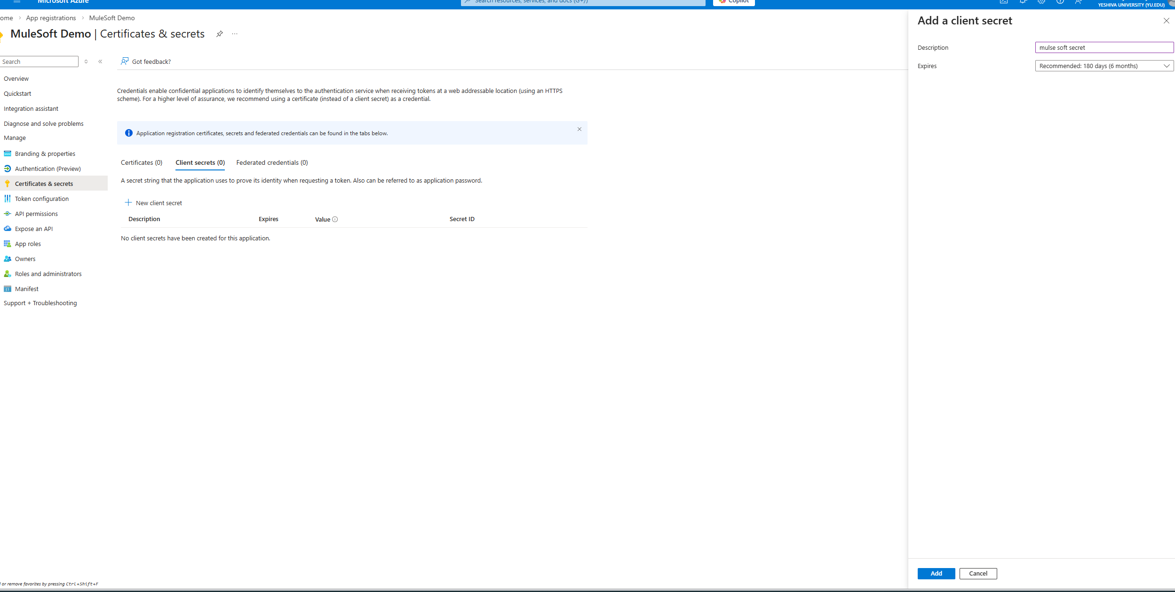
- Now we have all three id’s we need to connecting to mule (tenant id, client id and secret id)
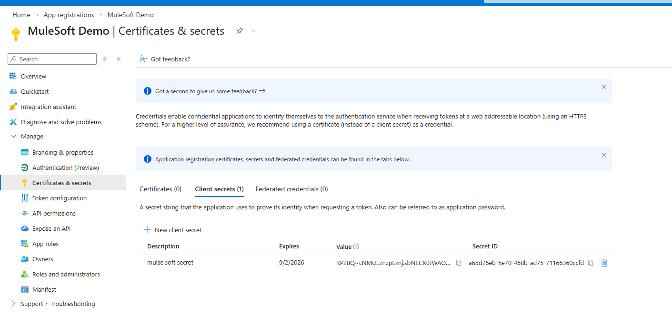
- Assigning API permission.
  - Click API permissions under manage.
  - Click API’s my organization uses and search “Microsoft.Servicebus”.
  - Click on user impersonation and add permission.
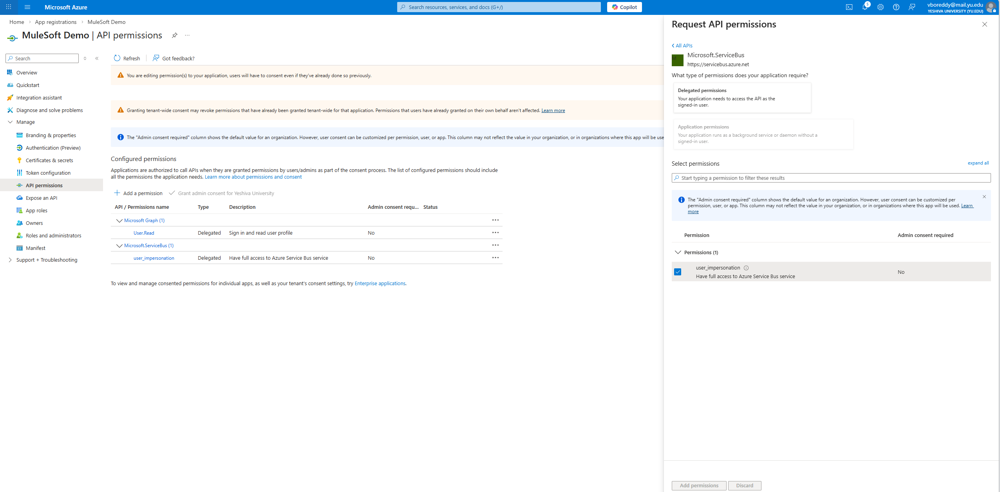
- We have given access to Microsoft service bus not that service bus namespace. So, we have to assign it to this app permission specifically.
  - Got to service bus -> Name space-> Access control-> role assignment -> add role
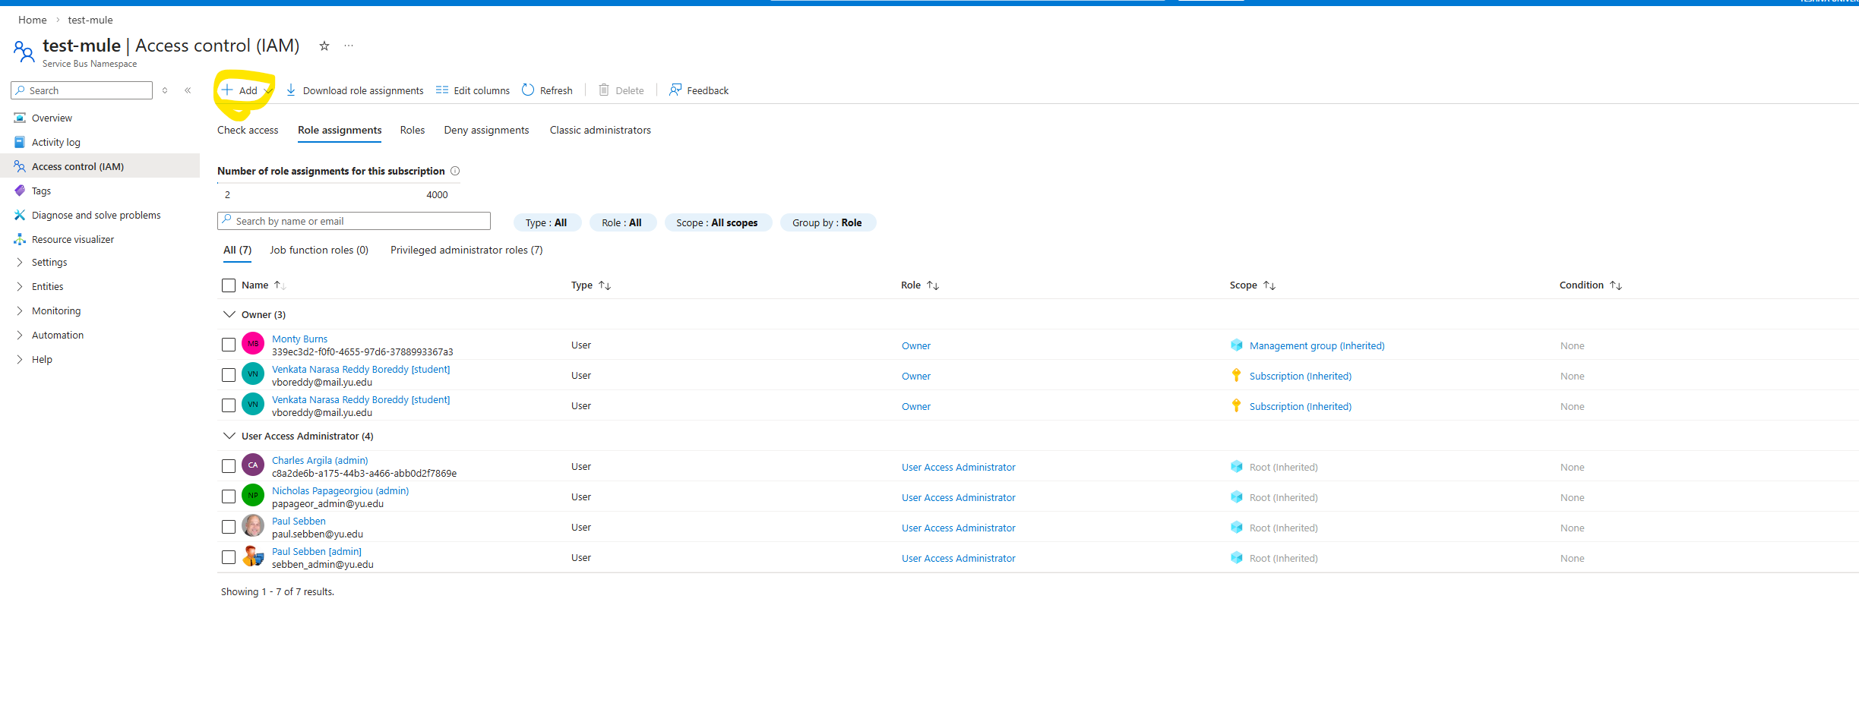
  - In roles search and select “Azure Service Bus Data Owner” which will give umbrella permission to both Receiver and sender.
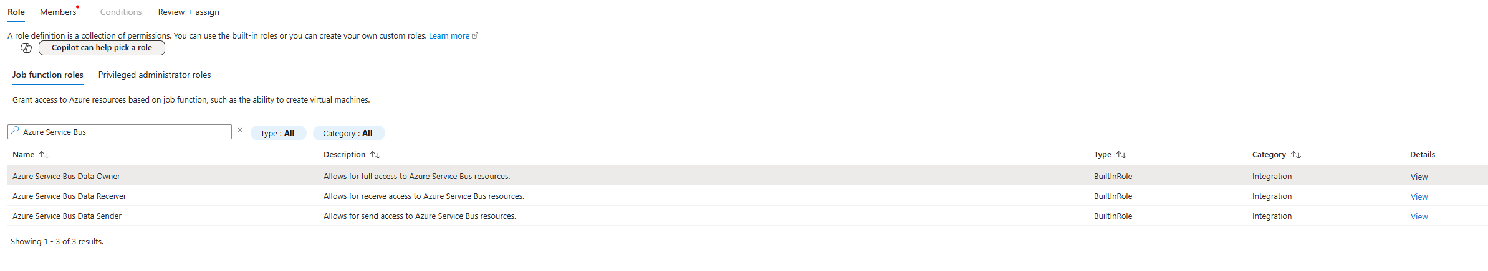
  - Click next. Click Select members -> search for our App registration name -> review and assign.
